3.9: a) Solving Eq. (3.18) with 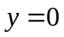, 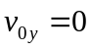 and 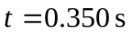 gives 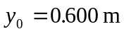.
b) 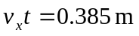 c) below the horizontal.
